PRACTICAL SESSION-5

TASK 1: Implement a producer-consumer communication system using anonymous pipes where the parent process generates data and the child process consumes it. Measure the communication efficiency.

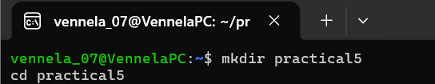
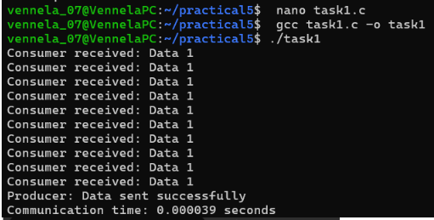

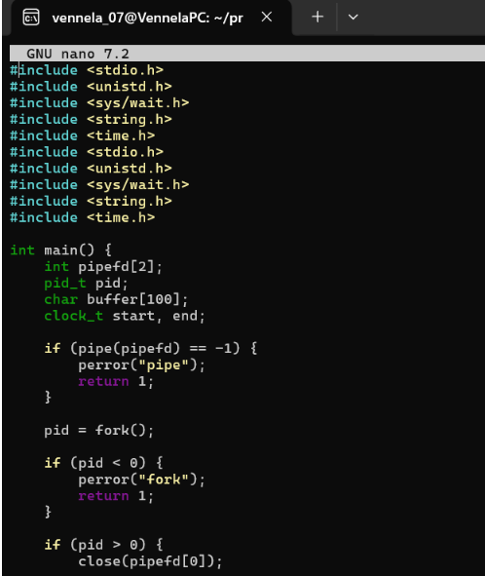
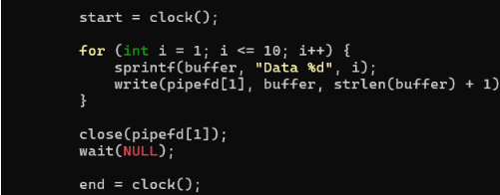
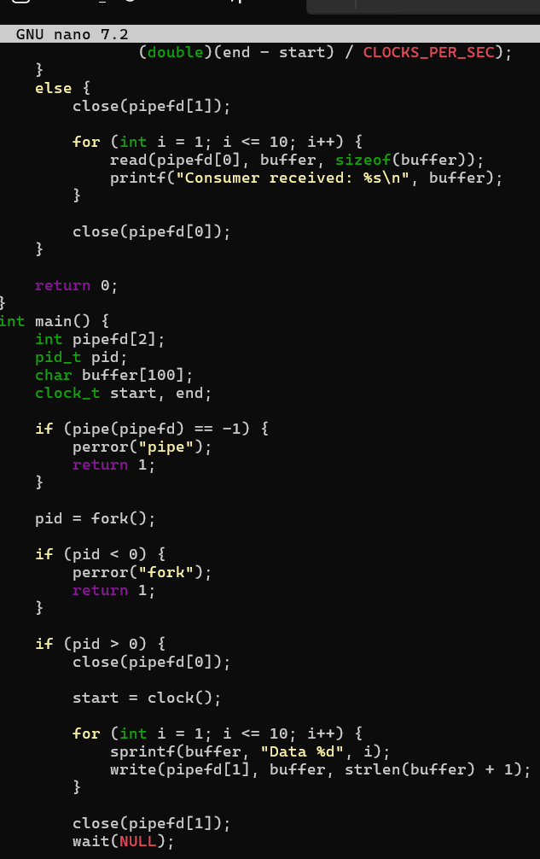
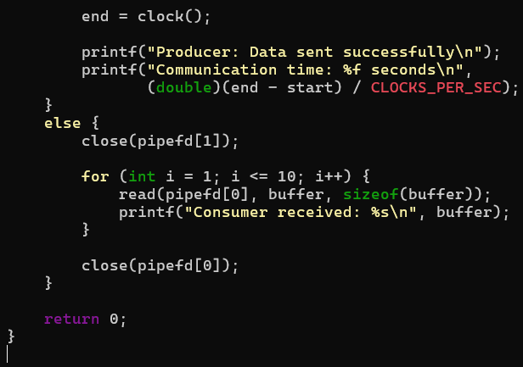

TASk2:Develop a program that executes the equivalent of the shell command: ls -l | grep ".c" using fork(), pipe(), dup2(), and exec() system calls.

